# Government Primary School Rajanukunte

Note: Add General description of government of Karnataka primary school

1)**In-Charge** **Head Master**: Shreenivasa G

Education: CPEd, Kan& Eng Sr typing, PUC

Date of Joining- 26-07-1994

Teaching Experience- 29 Years

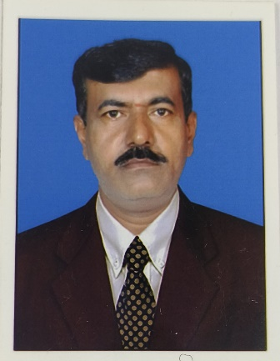

2)Veena T.S-

Education: PUC, TCH, B.Sc, B.Ed

Date of Joining- 31-07-2002

Teaching Experience- 22 Years

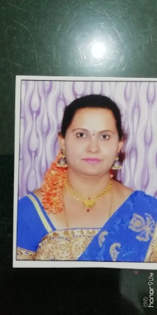

3)Kalpana T.R

Education: TCH, PUC

Date of Joining- 10-08-2002

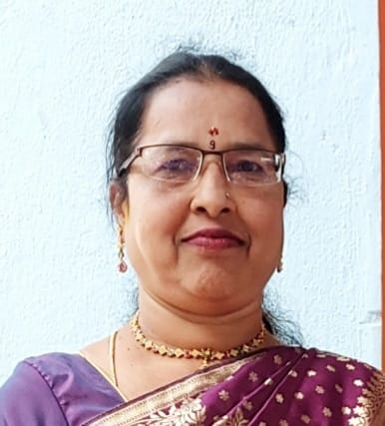Teaching Experience- 22 Years

4)Lalita Baby

Education: TCH,BA,PUC

Date of Joining- 25-08-2008

Teaching Experience- 16 Years

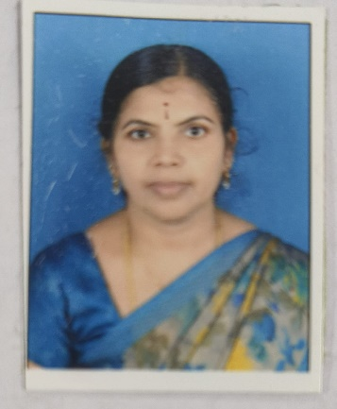

5)Soubhagya P

Education: MA, B.Ed,BA

Date of Joining- 09-03-2016

Teaching Experience-7 Years

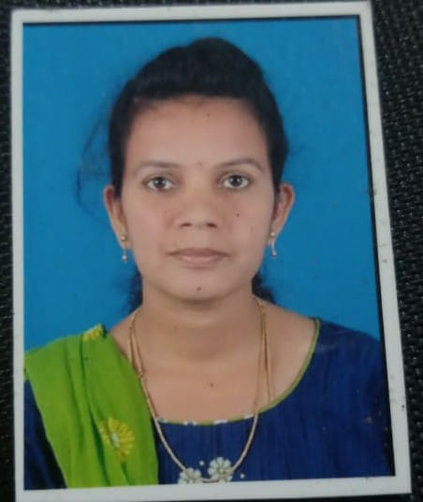

6)Lavanya C

Education: D.Ed, PUC

Date of Joining- 30-03-2016

Teaching Experience- 08 Years

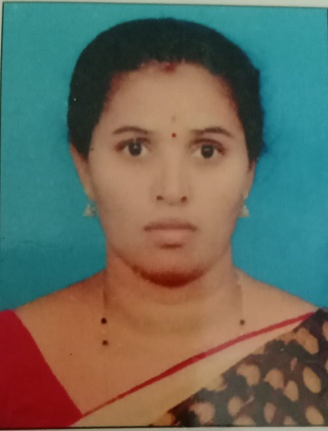

7)Soumya R

Education: MA,B.Ed, BA

Date of Joining- 06-06-2020

Teaching Experience- 4 Years

